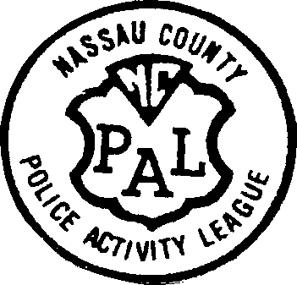

Bellmore/North Bellmore Unit

Fall Soccer Registration 2024

Boys and Girls

# Born between 2011-2020

**.**

.

Our “First Kicks” soccer program is for children 4 years of age entering Kindergarten in September 2024.

We also have a soccer clinic for children 5/6 years of age in Kindergarten.

These clinics will be conducted by **trainers.”**

They will both be held at the Winthrop Avenue School on Saturday mornings.

5 years old players in Kindergarten have the option of doing a clinic or being placed on a team in the kindergarten division of our Intramural league that plays on Sundays.

Our Intramural program is for players born between 2011-2019.

The intramural program will be held on Sundays at the (Nassau BOCES School at 2351 Jerusalem Avenue, North Bellmore)

(Intramural game times are between 11:00am-3:00pm)

(Practice schedules are determined by the individual coach)

# ONLINE REGISTRATION –

August 1st- September 10th

Intramural Registration Fee:

$105.00 – 1st child

$100.00 – 2nd child

Clinic Registration Fee: $100.00

**Uniform purchases-available: date to be determined.

Dates will be posted on our website

Mandatory uniform – reversible shirt, shorts & socks - $45.00

**\*\*THERE ARE NO REFUNDS\*\***

**\*\*VOLUNTEER COACHES NEEDED FOR ALL AGE GROUPS IN ORDER FOR PROGRAM TO WORK\*\***

**$50 credit will be given to volunteers that coach the whole season**

**For additional information: visit our website at** [**www.bellmorepal.org.**](http://www.bellmorepal.org/)